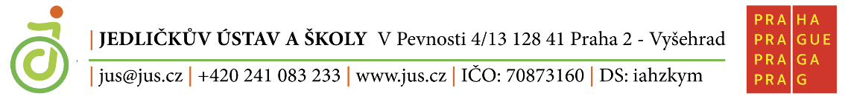

MATURITNÍ OKRUHY ANGLICKÝ JAZYK

- My Family and Relationships
- Work and Future Career
- School and Education
- Everyday Life and Routine
- Communication and Media
- Free time and Hobbies
- Food and Eating Habits
- Health and Healthy Lifestyle
- Culture and Traditions
- Houses and Living
- Travel and Transport
- Shopping and Services
- Nature and Environment
- Technology in Everyday Life
- Czech Republic and Prague
- English Speaking Countries
- Jedlička Institute
- Films and TV programmes
- Famous British and American people
- Cities and the Countryside

